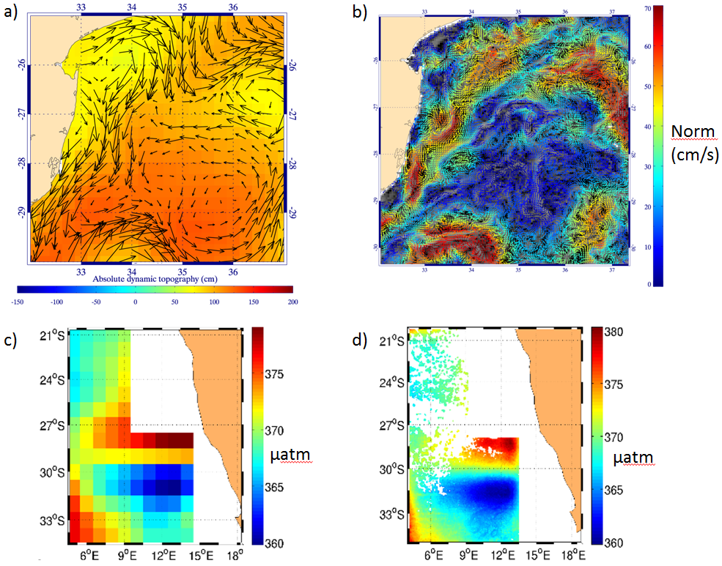

Fig 1 : Maps of (a) absolute dynamic topography at 1/4° and the LR current ( geostrophic and Ekman components) associated, (b) inferred HR current at 1/24°, (c) LR ocean pCO2 from Carbon Tracker at 1°, (d) inferred HR pCO2 at 1/32° .

